Royton Hall Primary School
Head Teacher: Mrs S Charlton

High Barn Street
Royton, Oldham
OL2 6RW
0161 770 7640
www.roytonhall-pri.oldham.sch.uk
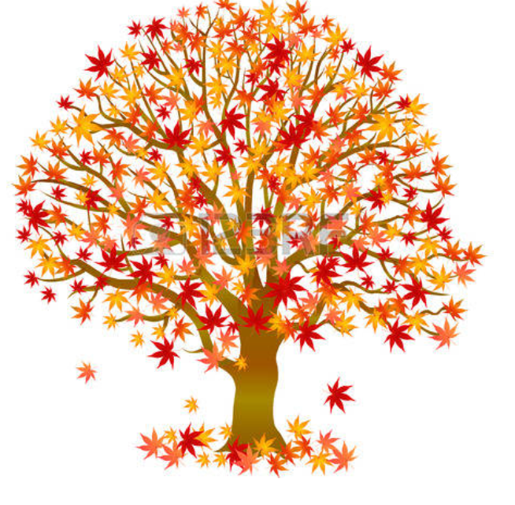
Monday 7th September 2026

NURSERY AND RECEPTION AUTUMN NEWSLETTER

Dear Parents and Carers,

A very warm welcome to those of you who are new to our school and those who are returning to us. We hope you all had a safe and happy summer and we are looking forward to getting to know you and making a positive start to the year.
In Nursery and Reception, our new topic is Marvellous Me. We will be learning about different families, how to make friends, similarities and differences, likes and dislikes, our community and our individual amazing talents and personalities.

We ask for your help with a few things to enable your child’s day to run smoothly:
- Please make sure everything your child brings to school is clearly named so that we can return misplaced items.
- When the yard shutters are opening, please closely supervise your child to ensure they are safe. Please wait for the shutter alarm to stop and you see the GO sign before walking underneath.
- We encourage all children to bring a book bag and water bottle every day.
- Please leave a change of clothes on your child’s peg.
- We discourage children from bringing unnecessary items back and forth to school in order to reduce any risk of the items being lost or broken.
- Long hair must be tied back for school for health and safety reasons.
- Please let us know if someone different will be collecting your child. We are not able to release children to anyone else without your permission.

Please ensure your child arrives on time every day, to give them the very best start to the school day. Our doors open at 8.40am for reception/full time & morning nursery and learning begins promptly at 8.45am. (For afternoon nursery, school begins at 11:45am). If you arrive at school after this time, make your way to the main office to sign your child into school.
At Royton Hall, we value the importance of working in partnership with you to help your child achieve the best they can in all aspects of their learning. If you have any questions or concerns relating to your child, please speak to your child’s class teacher. You can telephone or email the school office and we will reply as soon as possible – info@roytonhall-pri.oldham.sch.uk

Thank you for you continued support.
With kind regards,
The EYFS Staff

