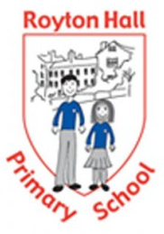

Royton Hall Primary Forest School
Information, policies and procedures handbook
2019-2020 / 2020-2021



Contents

Forest School at Royton Hall Primary
What is Forest Schools? 3
Designated Person Responsibilities 4
Our Forest School Site 5
Code of conduct 6

Health and Safety
Emergency Communication Plan …………………………………………………………………………….......... 12
First Aid and emergencies 14
Tool use policy 17
Food hygiene policy 18
Fire safety policy 19
Risk assessment 21

Procedures
Safeguarding/Equal opportunities/Confidentiality 22

What is Forest Schools?
Forest School is a unique outdoor educational experience which offers children the opportunity to develop social skills, confidence and self-esteem, through hands-on learning in a woodland environment. The Forest School concept originated in pre-schools in Denmark during the nineties. Practitioners found that when the children (whom had attended the Forest School) arrived at Primary school, they approached learning with confidence in their abilities, were able to work effectively in groups and also showed strong social and communication skills. These foundational skills, which contributed to their holistic develop, also helped them to raise their academic achievements.
At Forest School children are encouraged, through motivating tasks and activities, to instigate, test and allure a curiosity for the natural environments around them. Our Forest School sessions provide diverse independent and team-building opportunities for children to experience, which elicits a healthy range of emotions in order to build resilience and confidence within themselves. These will be appropriately challenging and achievable tasks, which will require their skills and independence as they are given time to explore their thoughts, feelings and relationships with others whilst doing so.

Designated Person Responsibilities
Class Teacher – Level 3 Forest School leader – Miss Linger – Outdoor Paediatric First Aid trained – Basic food hygiene trained.
HLTA – Level 3 Forest School leader – Miss Dutson – Outdoor Paediatric First Aid trained – Basic food hygiene trained.
Teaching assistant – Level 2 Forest School leader – Mrs Russell-Roberts – First Aid trained.
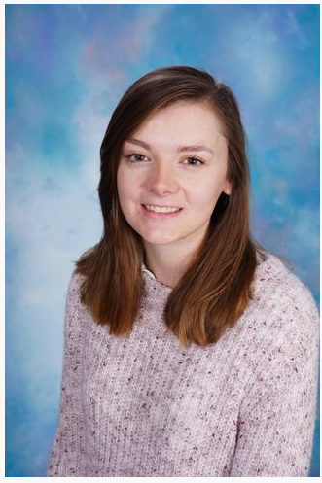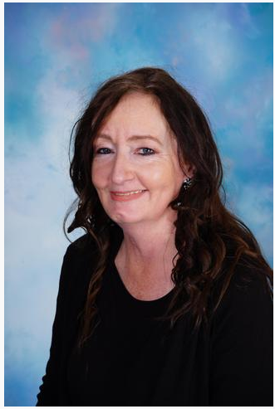
Both Level 3 Forest School leader’s roles are to lead the group, liaise with parents, lead sessions, provide appropriate equipment, ensure that health and safety procedures are followed correctly by all in attendance. To also check safety of woodland area and to ensure that appropriate site management is regularly undertaken (tree inspections, boundary fencing, litter, debris.) They will also record and observe children through notes and photographs. Level 2 Forest school leader’s assist with the activities being conducted within the environment by Level 3 leaders, also supervising the children and ensuring the safety of all.
Our Forest School site
Our Forest Schools site is nestled within the grounds of our school and is currently solely utilised by us, to protect the land and wildlife. As Forest School at Royton Hall was originally launched several years ago and then stopped, the site has evolved and changed, experiencing seasons of natural overgrowth. When we began Forest School again, it had been four years since it was last used. The old fire circle was unrecognisable and had become a hub for habitats and wildlife, thus we created a new one with ten freshly chopped up logs taken from one of our very own trees. Our new fire circle is the new hub for our explorers to rest, discuss and sit during the sessions. 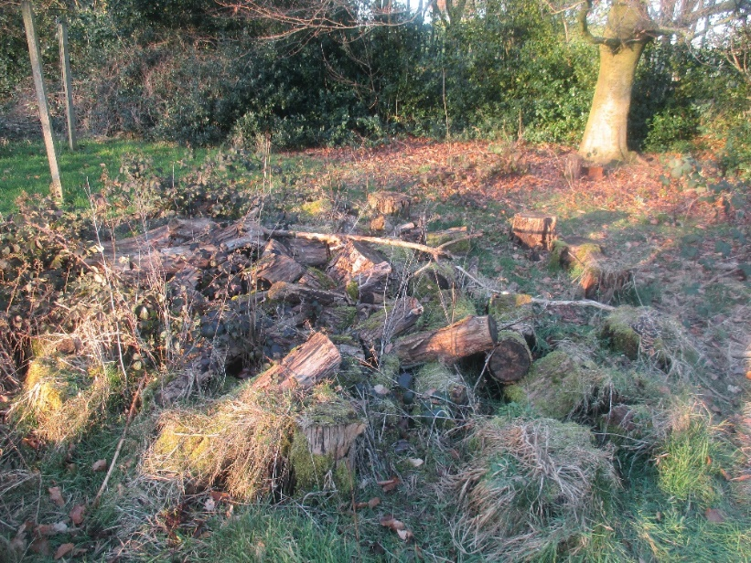
Figure 1 - The old fire circle
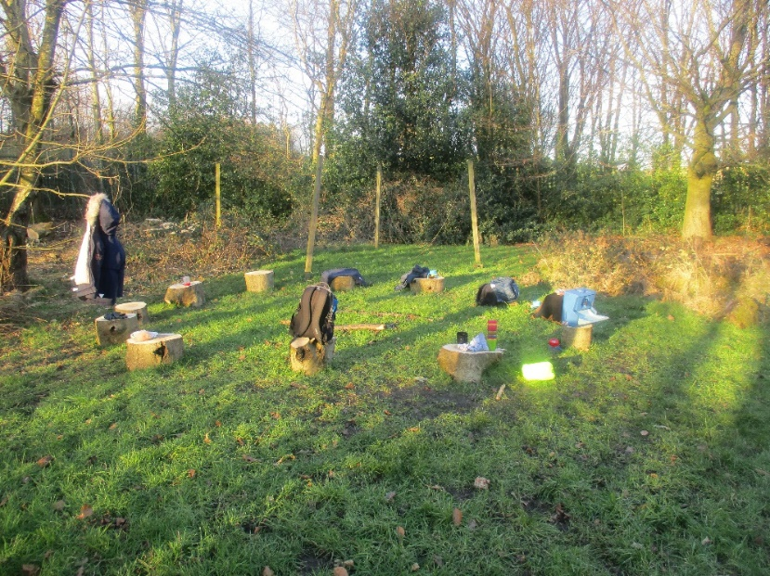
Figure 2 - Our new fire circle

Our Forest School code of conduct
Entering the Forest School site  When entering the Forest School site we treat it with respect and understand that our school expectations are in place. We will explore, investigate, create, learn and play in a way that will not damage our Forest School environment. We understand that we share our Forest school with plants and animals and show respect for their habitat. | 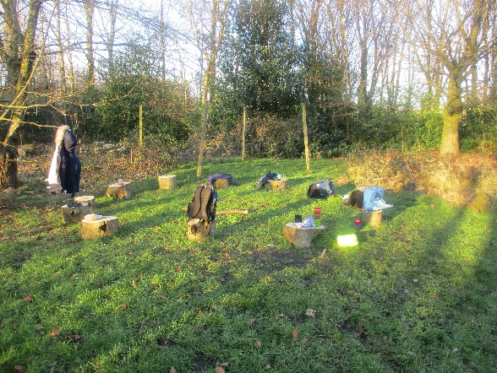  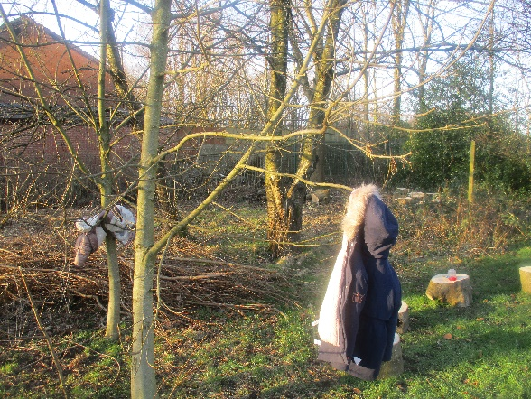
Boundaries  During each session the children will be shown/reminded of the boundaries in a natural way. The children have the freedom to explore the site independently. Adult supervision is given when children are climbing trees. Children will be taught a simple call and response game. ‘One, two where are you?’ for a visible head count/check and ‘One two, three come to me.’ for a recall. | 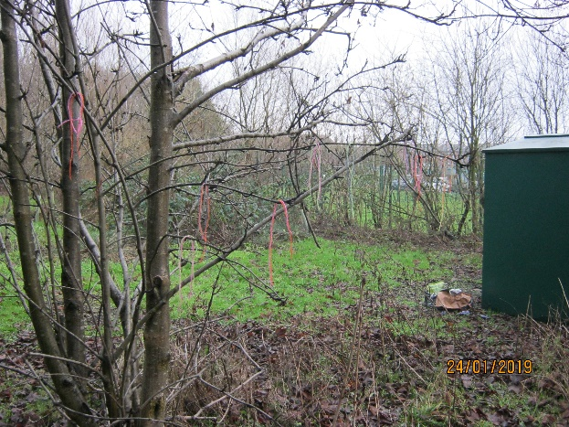
Carrying, collecting and playing with sticks  Children are taught to only carry sticks shorter than their arm’s length and to hold it pointing towards the ground. They are encouraged to think about the distance between themselves and others. Longer sticks can be carried with a child at each end. Logs can be moved by rolling or dragging along the ground. Sticks must never be thrown. | 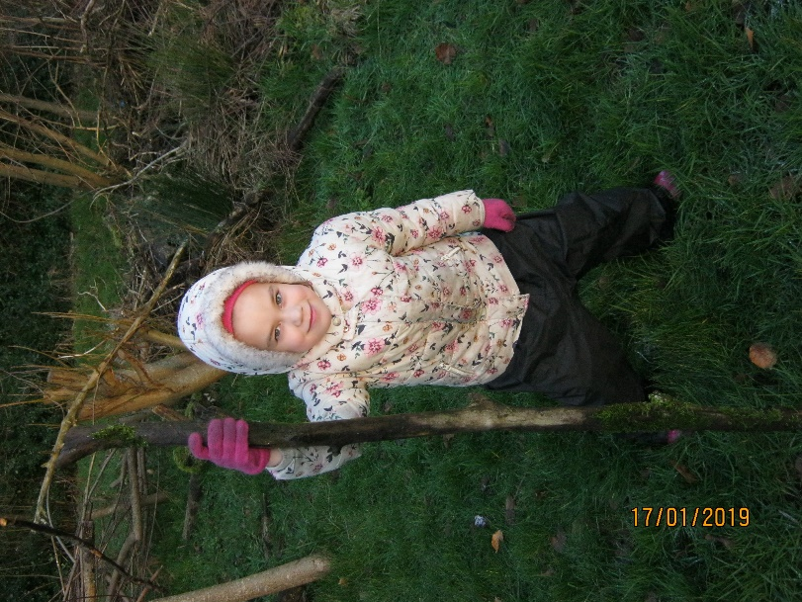
Investigating and exploring  Children are encouraged to engage in free play to allow natural curiosity. They may collect natural objects and can carefully move soil to look for insects and their habitats Care will be taken ensuring that habitats are not disrupted. | 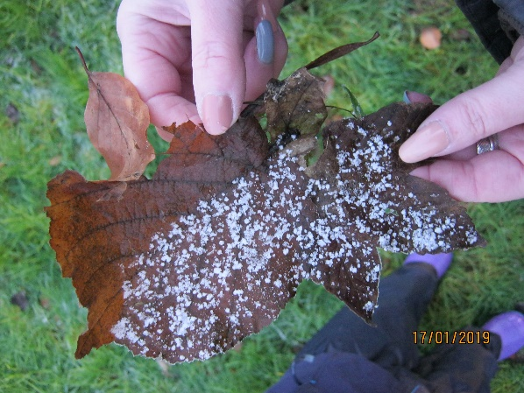
Collecting wood  Wood is collected for den building, creative activities and fire lighting purposes. It is collected sparingly so that habitats are not disrupted. Children are taught how to keep the Forest School sustainable | 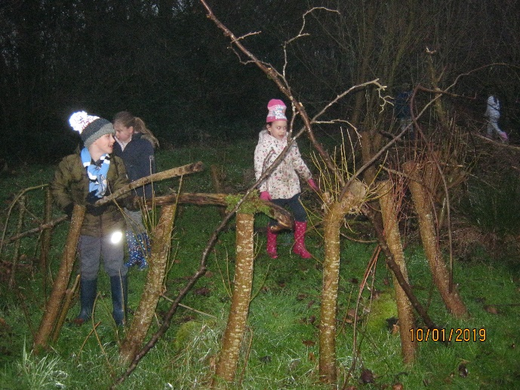
Eating and drinking  Chidren are not allowed to eat anything found within the Forest School site. We follow a strict no hands in mouth policy. When having drinks and snacks chidren will use the portable sink for handwashing before eating and drinking. Chilren are remimnded not to put their fingers in their mouths during the session.  Using rope and string  Children are taught a variety of knots for different purposes. When tying knots to support or transport something an adult will oversee and advise if necessary. | 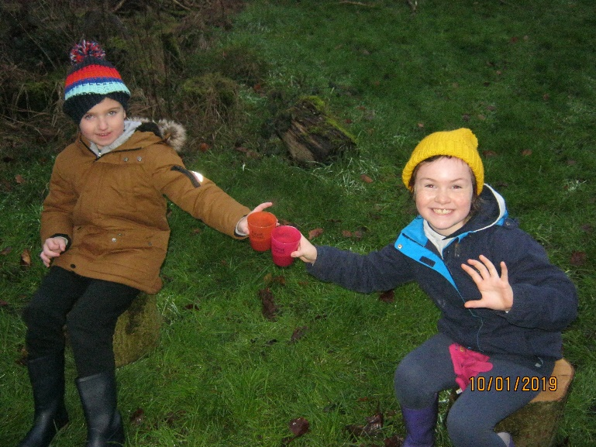  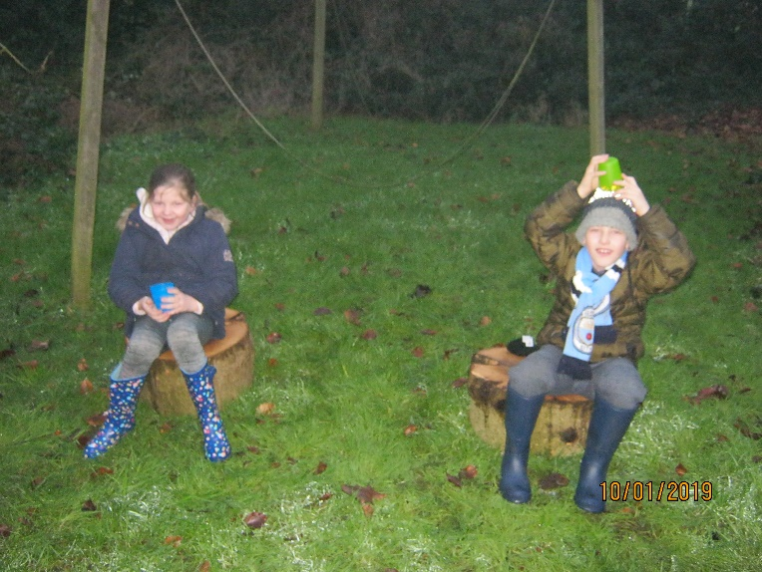
Tree climbing  Children are taught how to climb trees safely and correctly. A visual check must be made to look for loose, sharp and rotten branches. Appropriate clothing and footwear must be worn. Adults should be near enough to supervise children but not so close that it will be invasive to the children’s exploration. Children are allowed to explore to their own limits or to a maximum height of 1.5m. | 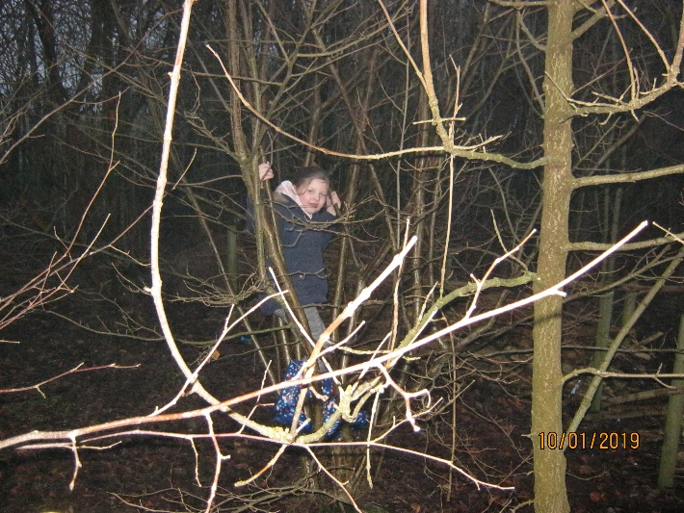
Leaving the site
Any imported materials that are not natural need to be removed. Any rubbish should always be removed. If items have been found or made these may be taken off the site with the consent of an adult.

Health and Safety
Emergency Contact Procedure
In the event of an emergency the following will happen;
- Children advised of tools down in surrounding areas and to await further instructions.
- Gather all the children together to a safe space (1, 2, 3 come to me).
- Forest School Leader to assess situation and remove any hazards.
If the situation and casualty is assessed as being treatable by First Aid trained FS Leader…
Adult 1 – Treat the casualty. Decision to be made as to whether… |  | Adult 2 – Lead other children to a safe space away from the casualty and conduct a head count. Await further instructions whilst keeping the children calm.
Child needs to go home. | Child may carry out the rest of the session. FS Leaders to monitor child.
Parent/Carer contacted by FS staff and informed of the incident and treatment. A FS staff member to wait with child to be collected at the office. | Inform the child’s adult when collected at the end of the session or over the phone and advised to monitor. | Session resumed and adults advised to gather together. Children advised of any additional information they may need to know to prevent further casualties.
Incident and treatment to be recorded in the incident book.
If the situation and casualty is assessed as being unable to treat alone by a First Aid Leader
Adult 1 – Treat the casualty and assess the severity. |  | Adult 2 – Lead other children to a safe space away from the casualty and conduct a head count. Await further instructions whilst keeping the children calm. Adult 3 - Inform SLT via mobile phone. Inform adults of the casualty and attending ambulance for the child, using emergency contact within the Happy Sack.
Phone 999 using mobile phone carried by the leader and inform emergency services of the casualty/severity and treatment. Stay on the phone to emergency services until they arrive.
Senior school leader to support and await ambulance to guide them to the site of the emergency. On arrival if parents have not arrived, SLT to accompany child in the ambulance. |  | Children gathered into School building.
Incident and treatment to be recorded in the incident book.

Health and Safety
First Aid and Emergencies
Royton Hall Primary School sets out clear statements of intent regarding the Whole School’s approach to health and safety of its children, staff and visitors to the School. This policy can be located on our School Website. Below is a list of additional measures which relate directly to our outdoor site and Forest School sessions.
- The Forest School leaders (Miss Linger and Miss Dutson) are qualified in Outdoor Paediatric First Aid and are at hand during Forest School sessions.

- The Forest School leaders have overall duty of care for the children in their charge. However, additional adults involved in the Forest School sessions are required to take all the reasonable steps to ensure that children are safe.

- A Forest School leader will always carry an Emergency Bag into the site for every session that will be kept in a central, accessible location.

- The holder of the Emergency Bag will ensure that it contains the following:
- A contact list including medical information for each child undertaking the activities
- Assigned medication for children if needed (such as inhalers, epi-pens)
- General First Aid kit
- Burns First Aid kit.
- Whistle

- The Forest School leaders will always carry a mobile phone.

- In the event of an emergency. A Forest School leader will ensure that the emergency services are contacted.

- A Forest School leader will review and complete a pre-visit check before every trip onto the Forest School’s site.

Health and Safety
First Aid and Emergency Procedures
During Forest School Activities on site:
• An individual has a minor accident - Eg, falls over, is stung by nettles, scratches: a first aider member of staff will treat with the first aid kit within the wood.
• An individual has a major accident – Eg, more serious falls, head injuries, cuts: A support staff member will walk quickly to the school office and arrange the contact of emergency services and/or the child’s parents/carers if appropriate. The support worker will then return to the wood on site to support where required. The Forest School Leader (qualified first aider) will stay with the injured child/adult. The remaining staff/helpers will arrange the safe removal of the other children back to the school.
• A Leader has an accident: if there are sufficient adults then one adult would remain with the leader whilst another adult removes the children from the wood into the school. If adults are needed to remain in the wood a responsible child would be sent to the reception with a red card, found in the first aid bag, to alert the school that help is needed to remove the children from the wood and for possible first aid assistance.
- Sudden evacuation of the woodland area: Forest School Leader to call out ‘1, 2, 3 return to base camp’ (if appropriate) whilst in a position where everyone can hear. Everyone is counted and then led out of the wood/back to the school/ Forest School Leader to lead the group and support staff to remain at the rear of the group

Health and Safety
Tool Use Policy
As part of Forest School, children will have the opportunity to use tools such as Bow saws, whittling knives and loppers to gather wood and other materials.
To ensure tools are used properly and responsibly, the Forest School leaders and additional adults will abide by the following procedures:
- The Forest School leader is responsible in training the children on how to use the tools and equipment safely and appropriately.

- A safety talk, specific to the tool, will be recited to the children before they use it.

- A protective glove is to be worn when handling certain tools, for example a bow saw.

- When tools are being used the adult child ratio will be 1:1.

- When using peelers for whittling the ratio can be 2:1.

- The Forest School leaders are responsible for the maintenance and checking of all tools and equipment to be used at the site, prior to their use.

- All tools will be kept in a lockable site within a locked building/shed.

- Children must never be allowed to help themselves and will always be supervised by an adult when collecting, transporting and using a tool.
Using and Storing of tools
All tools are counted out and back in at the beginning and end of each session in which they are being used. When the tools are not in use, they are kept secured away in a locked toolbox within the lockable Forest School shed. The Forest School leaders will regularly check the condition of the tools and their storage. In addition, all adults will model correct tool use, storage and transportation at all times.
Health and Safety
Food Hygiene
As part of Forest School, children may have the opportunity to cook on campfires. All procedures below to be followed:
- A full activity risk assessment which measures benefits and risks will be completed prior to preparing or consuming food items. This will include attention to the purchase, storage, serving and preparation of food.
- When food items are to be consumed during a Forest School session, water from a portable sink with an anti-bacterial soap will be provided for hand washing.
- Children and adults will be required to wash their hands before and safety touching or consuming foods.
- Children will be reminded not to put their fingers in their mouths during the sessions.
- All medical records must be checked to ensure no food item or ingredient is given to a child or adult with an allergy to it.
- Cooking on a campfire will be undertaken only by a member of staff in possession of a Food Hygiene certificate.
- Waste food will be disposed of promptly.
- Children are not allowed to eat anything found within the Forest School site. There is a strict nil by mouth policy.

Campfire Cooking Policy
- A risk/benefit activity assessment will be completed for all activities involving cooking on the campfire.
- Cooking on the campfire will only be undertaken by a trained Forest School practitioner.
- All hair will be tied back and loose clothing will be secured prior to cooking on the campfire.
- Children will be made aware of the boundaries around the fire circle prior to cooking on the campfire.

Health and Safety
Fire Safety
Campfires are an important part of Forest School and may be used during sessions. In preparation, we aim to ensure that all children and adults participating in sessions with fire, will do so safely and with as little risk to their health and safety as possible.
Location:
- Only the designated fire circle will be used for campfires and fire lighting.
- The fire will be made on level ground, avoiding tree roots, peat soil, rough ground, deep leaf mould and low branches
- Campfire area is to be enclosed by logs to prevent the spread of fire.

Positioning of Children and Adults
- Children are never allowed to enter the fire circle, even when there is no fire lit. They must treat the area, as if there is always a lit fire.
- When the fire is in use, children are not permitted to access the area, unless they are invited by the leader.
- When moving around the fire circle, everyone including children and adults must step outside the circle and walk around the outside.
- Once seated around the fire, the children must remain seated until directed by an adult.
- If there is a clear wind direction, seating in the line of smoke is to be avoided.
- If wind direction is variable, the leader should rearrange the seating if at all possible.

Safety and Responsibility
- A fire blanket, bucket of water and Burns kit must be sited close to the camp. Cling film is carried in the emergency bag.
- If sessions involve children adding fuel must be done with 1:1 supervision.
- Sticks/wood must be placed not thrown.
- A hand should never go over the fire.
- Never leave the fire unattended.
- Only qualified Forest School leaders will light the fire, unless children are under direct supervision.

Extinguishing
- All fires must be extinguished at the end of the session.
- Water must always be to hand during camp fire sessions.
- Whenever possible, all fuel should be burnt off to ash.
- At the end of the session, the fire must be doused down with water.
- Pot ash to be dispersed only when cold.
- Where possible, leave a no-trace fire.

Health and Safety
Risk assessment
Natural environments can be very unpredictable, so it is extremely important that risk assessments are created and reviewed regularly to ensure the safety of the children and adults accessing the Forest School site. To ensure the Forest School site is safe and ready for use, a detailed risk assessment looking at each layer of the woodland in the site will be assessed and created.
The following procedures will also be monitored:
- A risk assessment to be submitted to EVOLVE (a network overseen by the Business Manager and Head Teacher) before the sessions take place.

- Ratio of adults to children within a group 6:1

- If severe weather conditions arise, the Forest School Leaders will discuss and review the safety and comfortability of the site to decide whether it is safe to use or not.

Policies
Equal opportunities, Safeguarding and Confidentiality

Refer to the school website to find the policies above.

