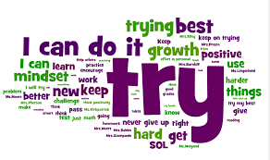
Maths: Everybody Can
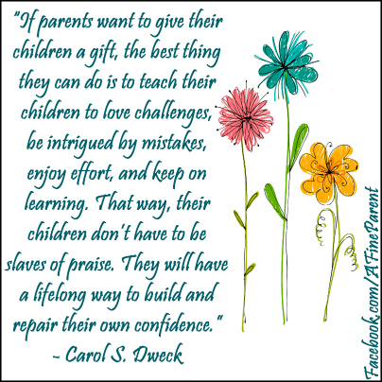
At Royton Hall we believe there is no such thing as a ‘maths person’ – no-one is born with a maths brain and no-one is born without: everyone has the potential to succeed in Maths. In all our lessons, it is important that our children understand how, with hard work, practice and belief, they will be successful in their maths work. Children are encouraged to talk about their work, discuss and explain their ideas and feel confident that mistakes and ‘re-thinks’ are all part of the mathematical learning process. Indeed, mistakes are celebrated as research shows that thinking about errors encourages ‘our brain to grow’ helping us to learn more.
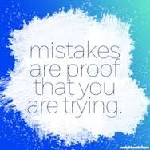
It is crucial that as a parent you promote the idea of a ‘growth mindset’. This means that children understand that with effort and hard work they can make progress in their work. Children (and adults) with a ‘fixed mindset’ believe that being good at something is already set and something they cannot control. This can have implications on your child’s capacity for learning.
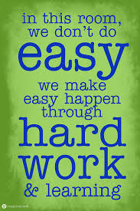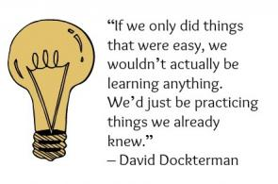
For more information on Growth Mindsets and how you can promote a positive attitude to learning maths, see the links below:
https://vimeo.com/173324233
http://www.bbc.co.uk/cbeebies/grownups/help-your-child-try-new-things
https://bhi61nm2cr3mkdgk1dtaov18-wpengine.netdna-ssl.com/wp-content/uploads/2016/03/Parent-Night-Handout-vF-1.pdf
http://www.beachborough.com/wp-content/uploads/2015/06/Beachborough-Parents-Guide-to-Mindset-Booklet.pdf


